**IT2120- Probability and Statistics**

**Lab Exercise 9 (Statistical Inference)**

**IT24103034**

1. Assume that the time taken to bake a batch of cookies is normally distributed with mean 45 minutes and standard deviation 2 minutes.

i. Generate a random sample of size 25 for the baking time.

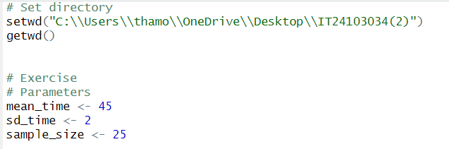

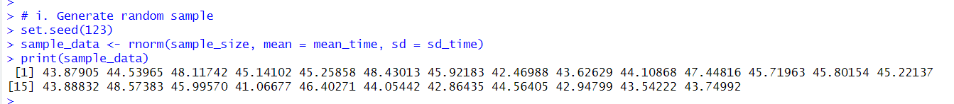

ii. Test whether the average baking time is less than 46 minutes at a 5% level of significance



